**To Supply Leftover Food to Poor**

Submitted by -Illakiya N

Saveetha Engineering College

**Activity 1: Creating Developer Account:**

[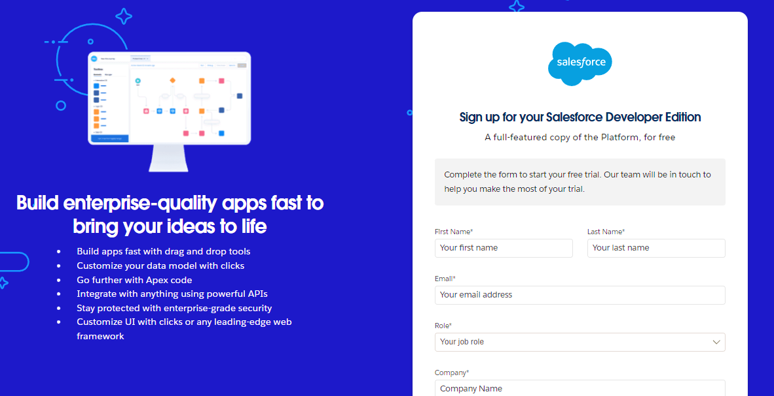](https://developers.salesforce.com/Signup*)

**Activity 2: Account Activation:**

1. Go to the inbox of the email that you used while signing up. Click on the verify account to

activate your account. The email may take 5-10mins.

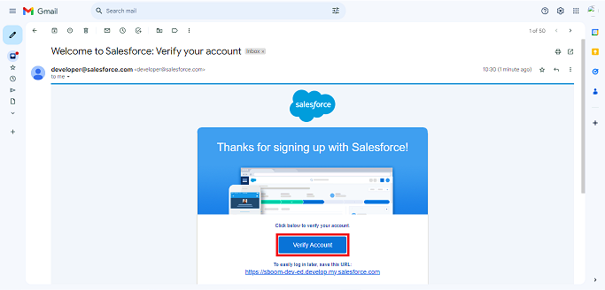

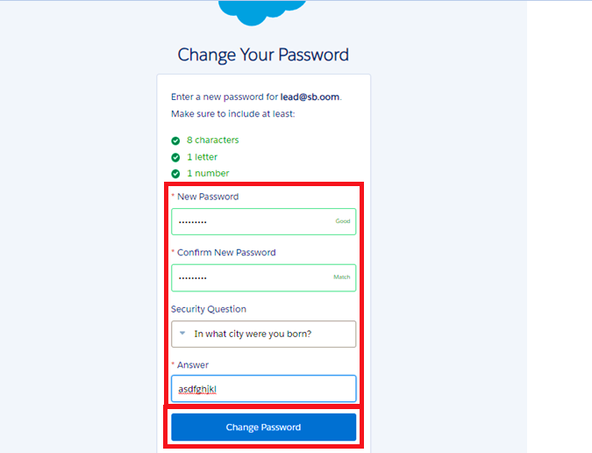

1.

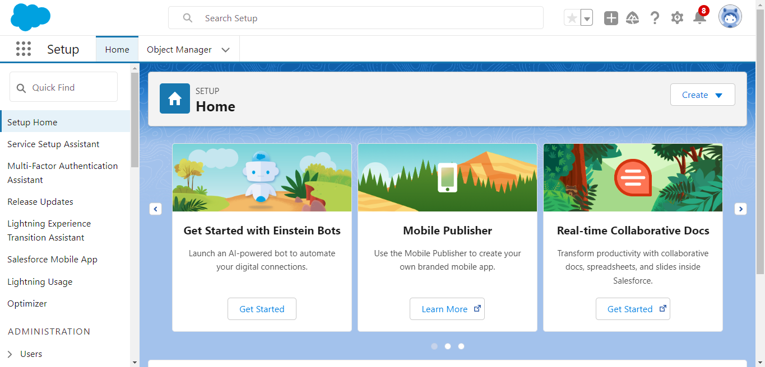

**Milestone 2- Object**

**To Navigate to Setup page:**

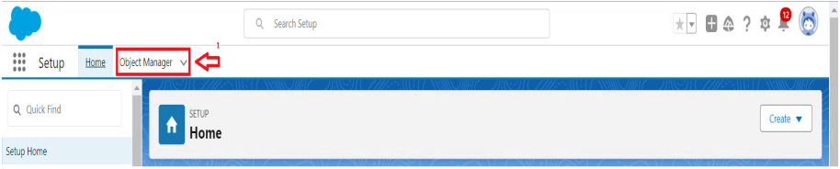

**To create an object:**

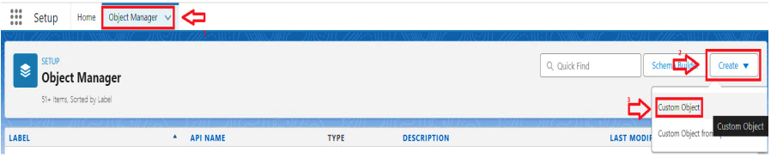

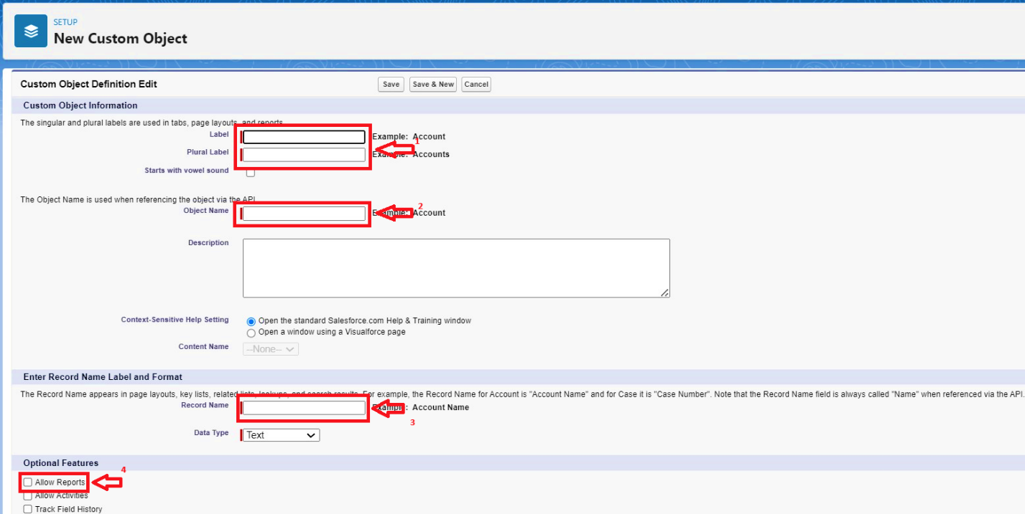

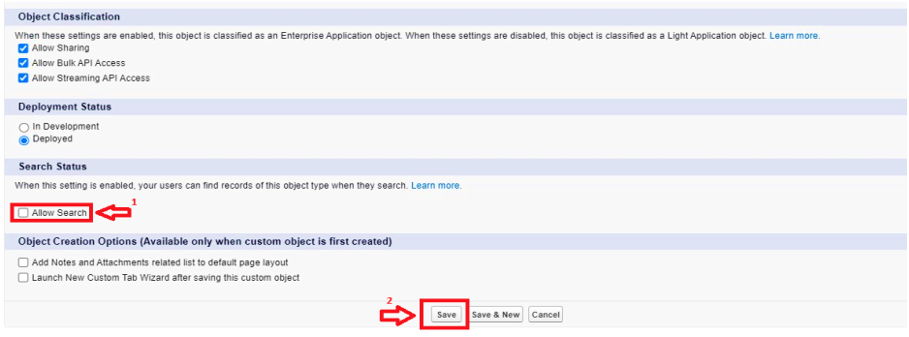

**Creating a Custom Tab**   
**To create a Tab:(Venue)**

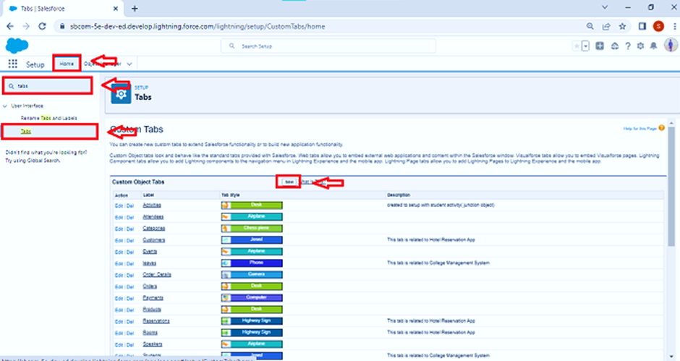

**Milestone 4 : The Lightning App**

**Activity 1: Create a Lightning App**

**To create a lightning app page:**

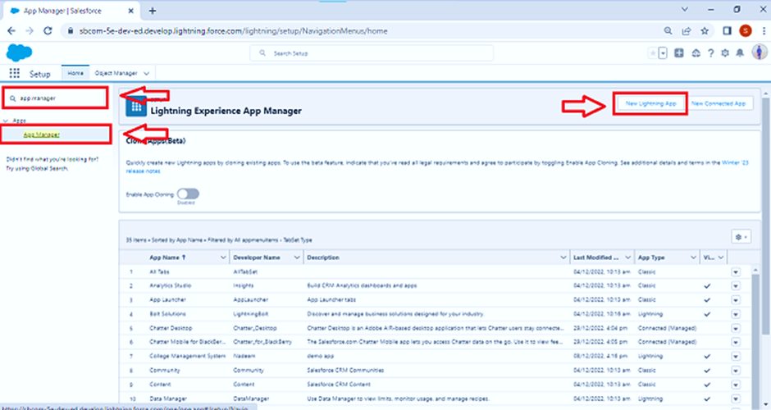

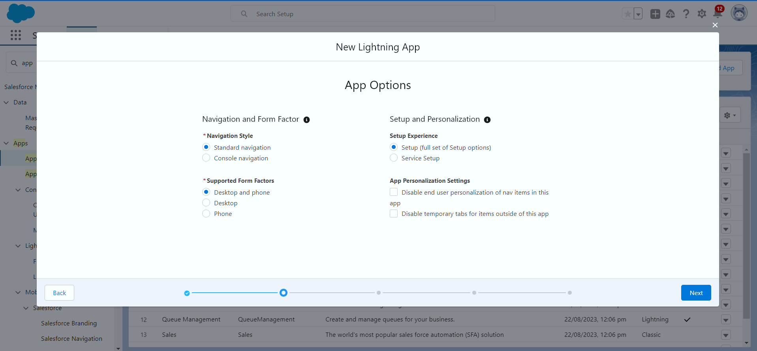

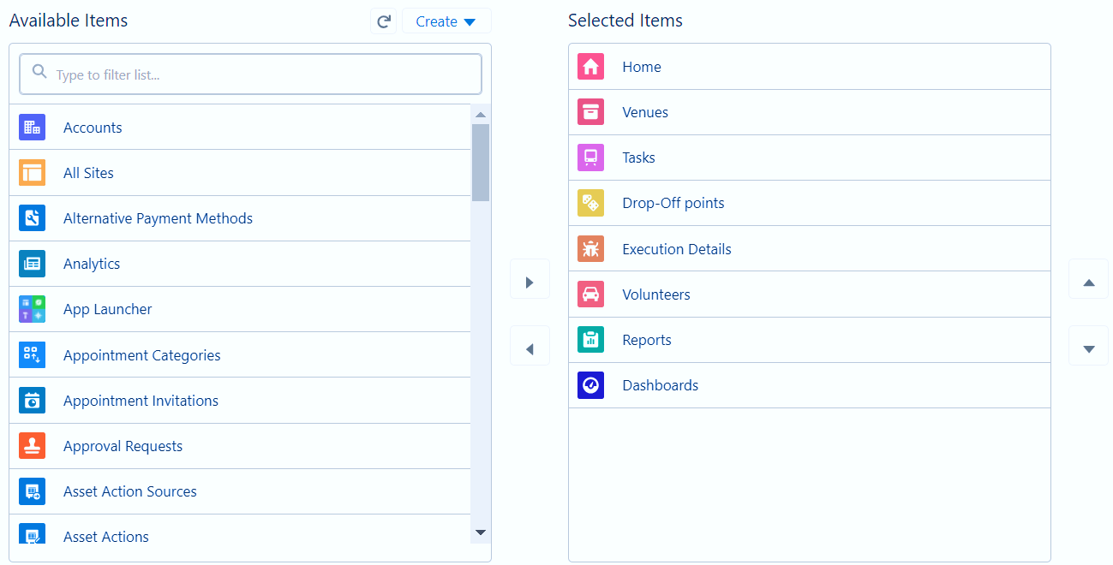

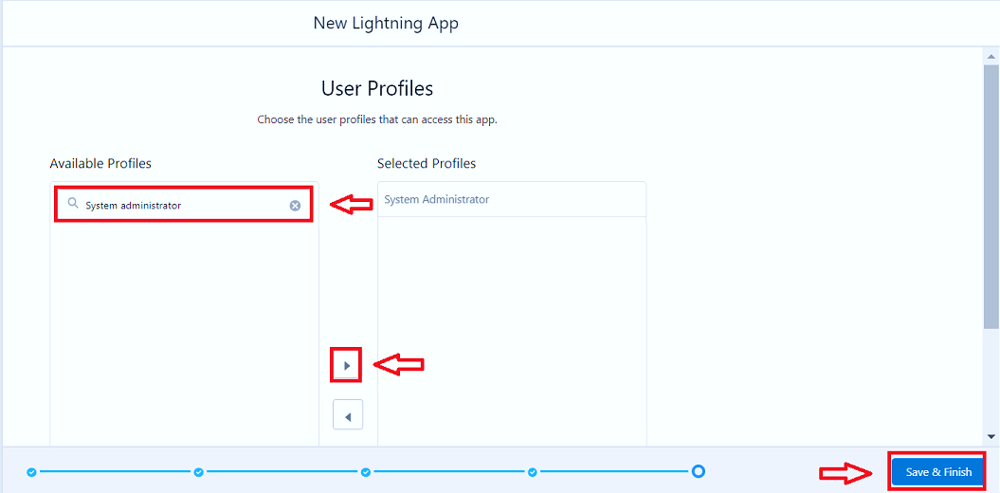

**Milestone 5 : Fields**

**Activity 1: Creation of Relationship fields in objects**

**Creation of Lookup Relationship Field on Volunteer Object :**

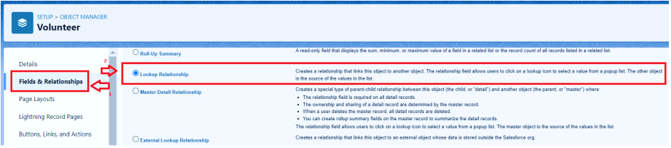

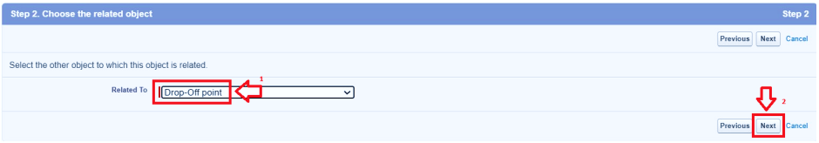

**To create another fields in an object:**

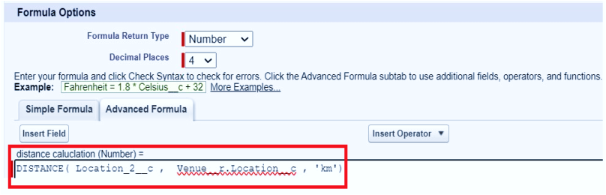

**Milestone 6 : FLOWS**

**Activity 1 : Create Flow to create a record in Venue object:**

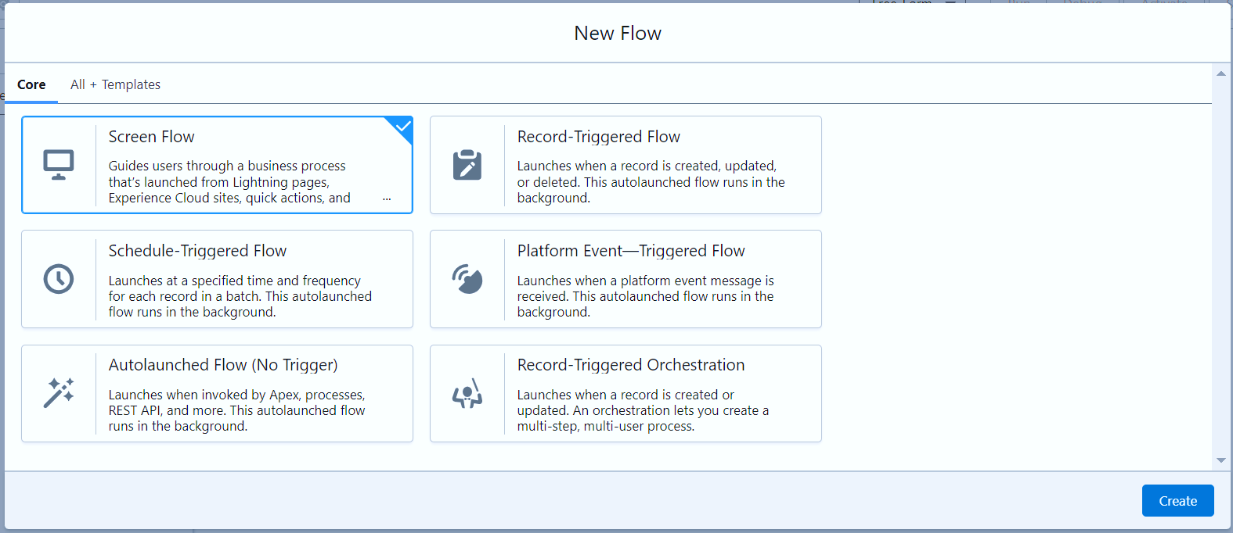

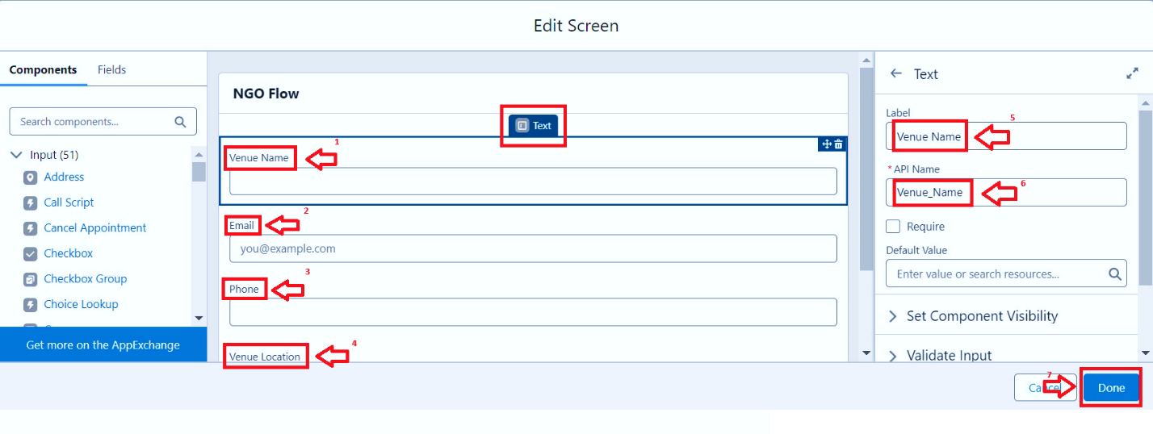

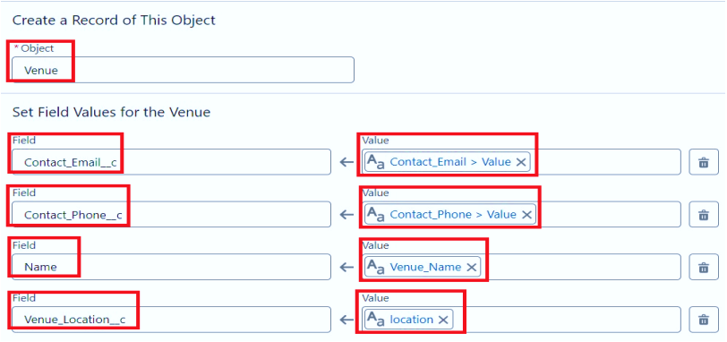

**Milestone 7 : Trigger**

**Activity 1 : Create a Trigger.**

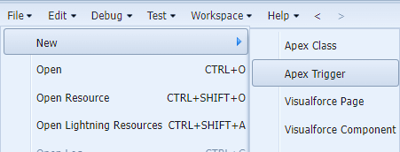

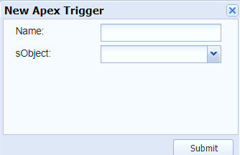

**Milestone 9 : Creation of Users (In our Project we consider them as NGO’s).**

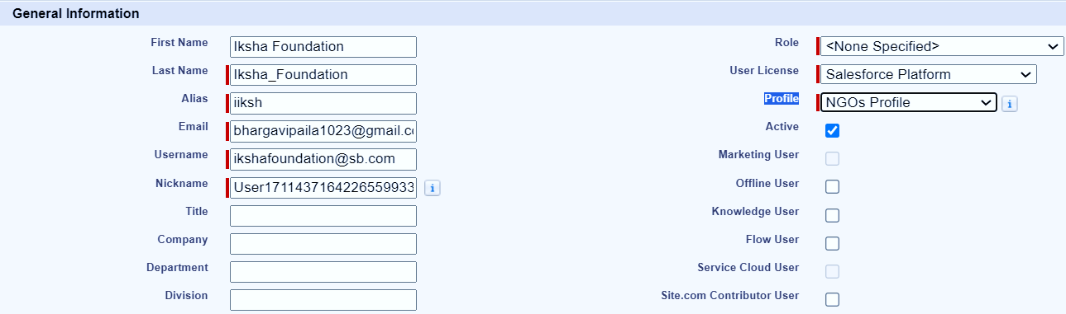

3. Click on Save

**Activity 2 : Creation of User2, User3**



**Activity 2 : Creation of Public Group 2.**

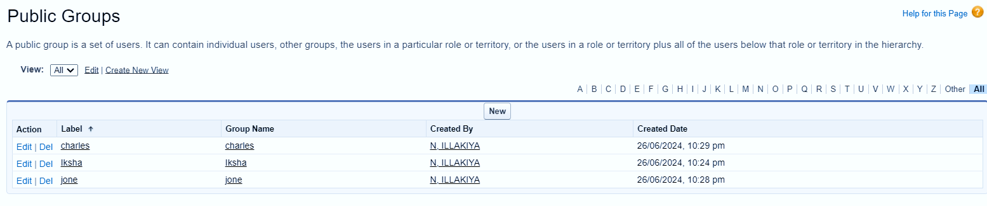

**Milestone 12 : Reports**

**Activity 1 : Creation of Report on Venue with DropOff with Volunteer**

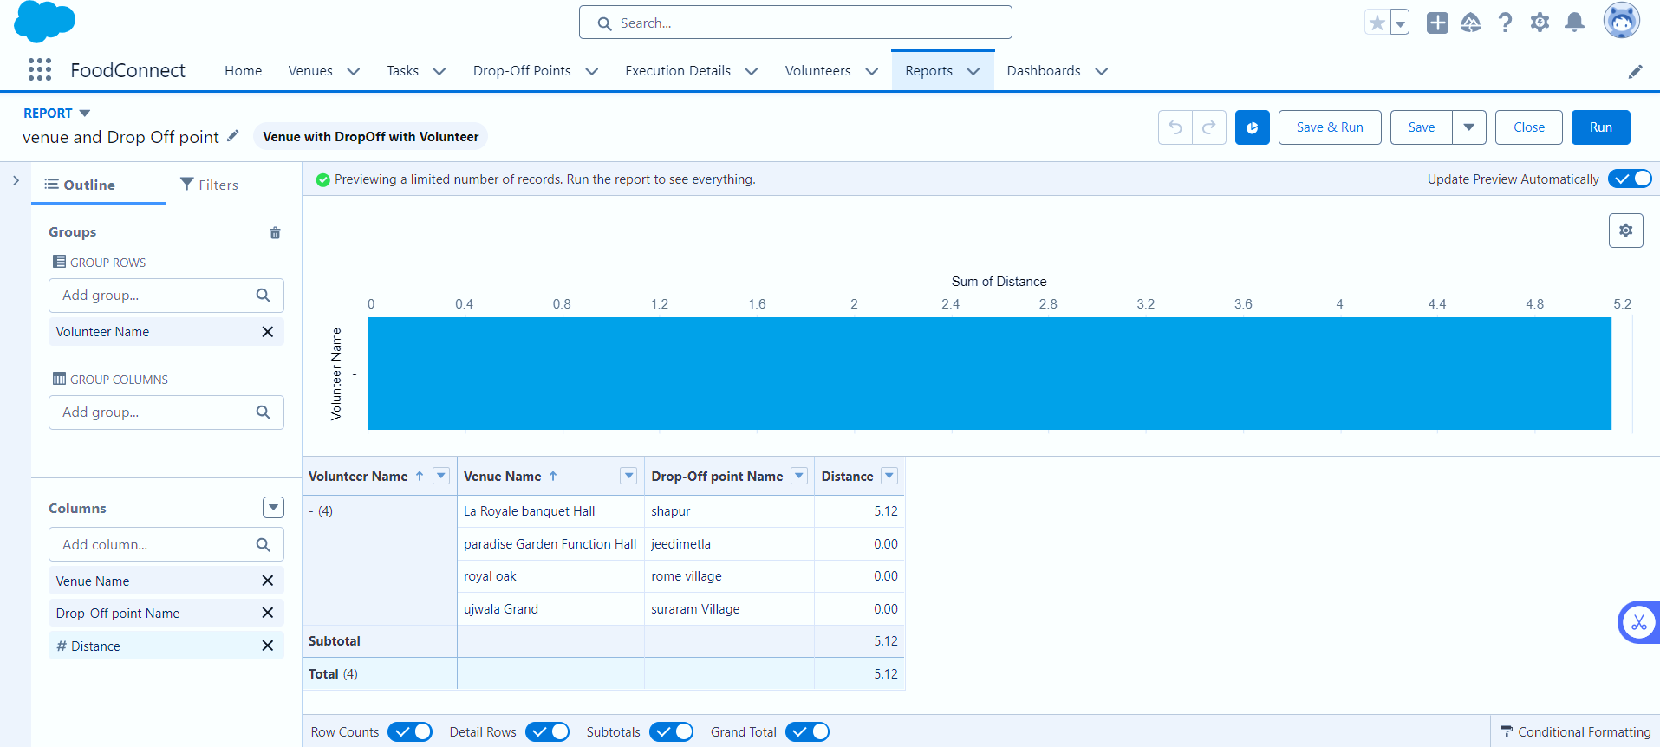

**Activity 2 : Creation of Report on Volunteers with Execution Details and Tasks**

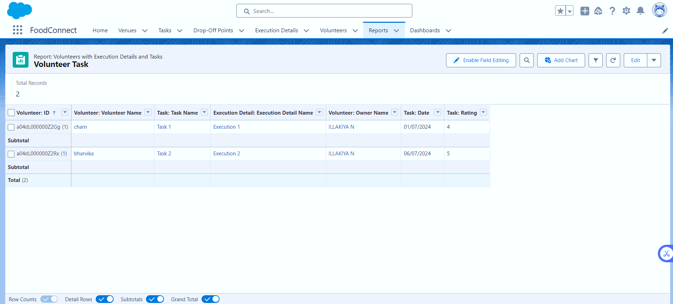

**Milestone 13 : Dashboards**

**Activity 1 : Adding venue and Drop Off point Report to the Dashboard**

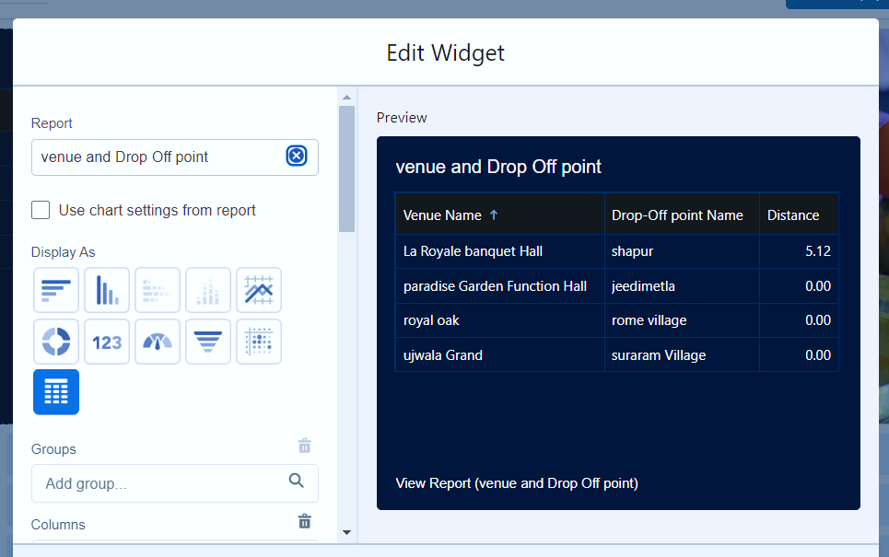

**Activity 2 : Adding Volunteer Task Report to the Dashboard**

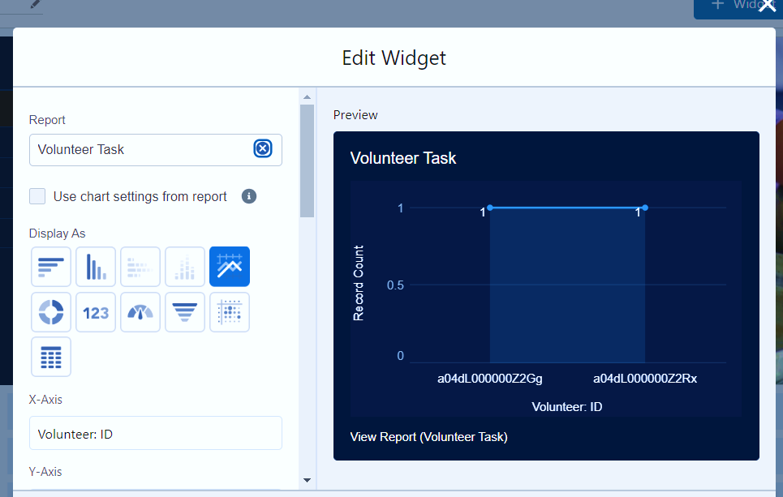

**Activity 3 : Adding a Picture to the Dashboard (Optional)**

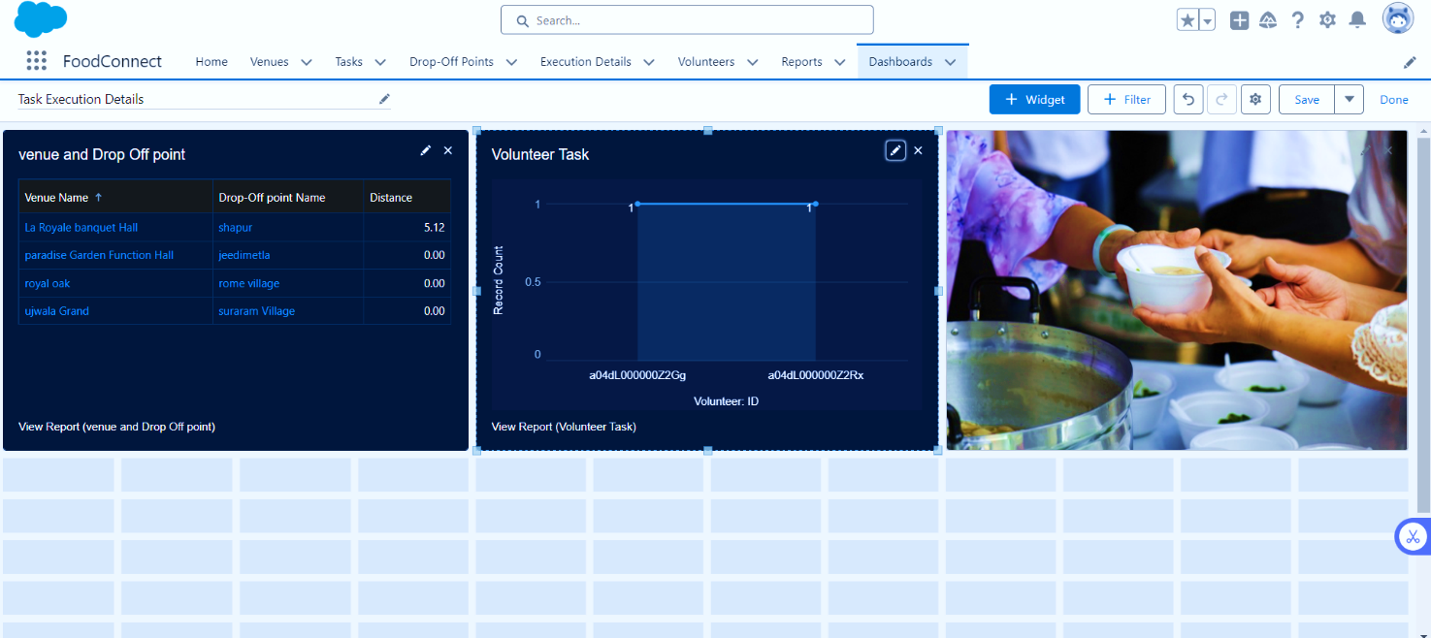

**Milestone 14 : Sharing Rules**

**Activity 1 : Creation of sharing rules**

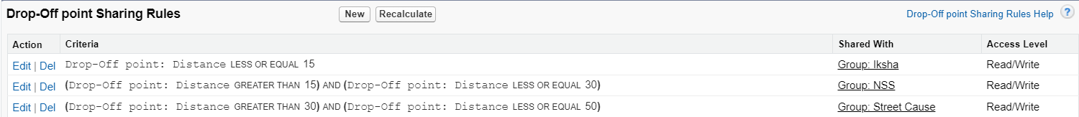

**Milestone 15 : Home Page**

**Activity 1 : Creation of Home Page**

